BSc(Hons) Business Information Technology/ BSc(Hons) Computer Forensics/ BSc(Hons) Computer Forensics & Security/ BSc(Hons) Computer Security & Ethical Hacking/ BSc(Hons) Computing
Courses 2016/17
Level 6 Production Project
Name: Atut Gorkhali | Student I.D.: 77178367
Course: BSc(Hons) Computing | Supervisor’s Name:  Basanta Joshi
FINAL PROJECT INDIVIDUAL AIM & OBJECTIVES
Title of my Project:
Research on NoSQL Database technology through development of a web based RESUME Portal
Aim of my Final Project:
The overall aim of this project is to study NoSQL database technology performing critical analysis against traditional SQL Database. Later phase of the project would develop an Online Web based resume portal using MongoDB to study implementation of NoSQL database.

Objectives of my Final Project:
- Perform research on NoSQL and NoSQL based database technologies to understand potential benefits and limitation of MongoDB on the resume portal
- Define Software Specifications Using MoSCow method
- Define software specification and analyse the Requirements for the software development
- Design the system diagrams such as Use case diagram, Context diagram etc.
- Design and develop MongoDB database solution for the resume portal using C# MongoDB driver
- Design responsive user interface solution for the resume portal using HTML5, CSS3, Bootstrap, JQUERY etc.
- Develop authentication module with password encryption using C# Asp.Net MVC framework
- Develop resume profile module to allow user to create and modify resume
- Implement client side and server side validation
- Develop or try to develop should have and could have portion of the project.
- Insert large data into database using mock CSV file and carryout compatibility, unit testing and code review
- Evaluate the use of NoSQL database in the developed software solution and potential improvement areas
Specification of my Final Product:
This project would critically analyse the NoSQL technology in two phases. The first phase of the project studies various aspects of NoSQL DBMS technology to understand their benefits and limitations. Meanwhile Second phase of the project would develop an Online resume portal implementing MongoDB as database solution. MongoDB has been selected as its free and open source (Ming Wu, 2015). Resume portal system would allow user to own a URL that would be linked to their public RESUME page. This portal would allow user to setup resume page and publish them. Moscow approach is taken here to define complete project specifications.

Must Have
- MongoDB database as NoSQL solution
- Sign Up module
- Login module
- Password reset via Email
- Username and Password encryption using MD5 algorithm
- Use of MVC approach during development of software
- Allow user to add education background, personal information, skills and working experience
- Allow user to print hardcopy of RESUME with modern layout
- Allow User to see the resume preview

Should Have
- Allow to user the select different RESUME layout theme
- Allow user to search resume based on education, location, skills and experience
- Allow user to set security on what to show publicly and what not to show
- Email Confirmation to register new account

Could Have
- Allow user save multiple RESUME
- Provide user different default RESUME layout based on their profession.
- Develop different module that would allow developer user to upload Resume layout
- Allow user to upload their resume file and take necessary information from file.
- Implement Captcha for additional level of security to prevent bot attack

Potential Benefits and Limitation of Project

NoSQL is relatively new and very on demand technology. This project would allow to learn different aspects of this technology which is itself a benefit. Scalability and its cheap hardware requirements can become key benefit while developing a web application which would have very large number of users. As the number of users would increase use of MongoDB could give advantage. However, Gupta Edward and Sabharwal (2015) writes NoSQL offers some limitation as it’s still not mature enough. This project would try to study limitations of this database technology.

Future Changes
In future, a Web API can be developed for the proposed resume portal that would be similar to Facebook API or twitter API. This would allow users to login into different third party website such as job portals and use information stored in the resume portal.

Rationale
In recent year, ‘Not only SQL’ also knows as NoSQL has achieved huge popularity to develop database solution. NoSQL has been best known for its scalability. This project would perform a critical study on such technology and understand underlying benefits or limitations and identify suitable scenarios. As it’s a relatively new technology, researcher would look to gather various finding against alternative traditions database technologies. This would help to raise the knowledge on a subject that is not only outside academic course but also highly in demand.
Another stage of the project would develop an Online Resume portal solution. This idea is not selected just to provide demonstration of NoSQL database deployment but rather I found this an interesting topic. Every time when someone tries to apply for a vacant post he/she requires to send Resume to the company. I came up with project to not only implement MongoDB as part of NoSQL study but to develop a solution that would help users to send resume by sharing URL link rather than the whole document or physical resume itself. Various front-side as well as server-side scripting languages would be used to develop the proposed software. At the end of this project I hope to improved my study, analytical and programming skills.

PROJECT PLANNING DOCUMENTS
To organize and plan the overall project, whole project is broken into smaller tasks. As part of this process work breakdown structure is created. WBS for this project is attached below.

Work Breakdown Structure
Name | WBS | Start | Finish
Planning and Analysis | 1 | Wed 8/24/16 | Tue 9/27/16
Initial Project Plan | 1.1 | Wed 8/24/16 | Wed 8/31/16
Identify Project Idea | 1.1.1 | Wed 8/24/16 | Wed 8/24/16
Initial Project Idea Discussion with Tutor | 1.1.2 | Thu 8/25/16 | Thu 8/25/16
Define Initial Project Aims and Objectives | 1.1.3 | Thu 8/25/16 | Thu 8/25/16
Initial Project Specification | 1.1.4 | Thu 8/25/16 | Fri 8/26/16
Initial Research Project Title | 1.1.5 | Fri 8/26/16 | Mon 8/29/16
Conduct Initial Research | 1.1.6 | Mon 8/29/16 | Wed 8/31/16
Initial Bibliography | 1.1.7 | Mon 8/29/16 | Mon 8/29/16
Feedback from Tutor | 1.1.8 | Mon 8/29/16 | Mon 8/29/16
Initial Project Plan Project Contract | 1.1.9
Component 1 Project Contract | 1.2 | Mon 8/29/16 | Mon 9/5/16
Review the Initial Project Plan Feedback | 1.2.1 | Mon 8/29/16 | Mon 8/29/16
Final Project Title | 1.2.2 | Mon 8/29/16 | Mon 8/29/16
Final Project Aim | 1.2.3 | Mon 8/29/16 | Mon 8/29/16
Final Project Objective | 1.2.4 | Tue 8/30/16 | Tue 8/30/16
Final Project Specification | 1.2.5 | Wed 8/31/16 | Wed 8/31/16
Final Rationale | 1.2.6 | Thu 9/1/16 | Thu 9/1/16
Final Research Title | 1.2.7 | Fri 9/2/16 | Fri 9/2/16
Finalize Initial Research Outline | 1.2.8 | Fri 9/2/16 | Mon 9/5/16
Final Bibliography | 1.2.9 | Mon 9/5/16 | Mon 9/5/16
Resource Requirement Planning | 1.3 | Mon 9/5/16 | Tue 9/27/16
Physical Resource Plan | 1.3.1 | Mon 9/5/16 | Tue 9/6/16
Human Resource Plan | 1.3.2 | Tue 9/6/16 | Wed 9/7/16
Component 1 Project Contract Submission | 1.3.3 | Wed 9/7/16 | Mon 9/19/16
Review the Resource Plan and modify if change in specification/Objectives | 1.3.4 | Mon 9/19/16 | Mon 9/26/16
Receive Formative Feedback | 1.3.5 | Mon 9/19/16 | Mon 9/19/16
Further Update on Project Contract | 1.3.6 | Mon 9/19/16 | Mon 9/26/16
Submit Final Project Contract | 1.3.7 | Mon 9/26/16 | Tue 9/27/16
Online Ethics Form Submission | 2 | Tue 9/6/16 | Wed 9/7/16
Final Component 1 Project Contract Complete | 3
Design | 4 | Tue 9/27/16 | Tue 10/25/16
Design software system using tools | 4.1 | Tue 9/27/16 | Tue 10/4/16
Design MongoDB model database solution | 4.2 | Tue 10/4/16 | Wed 10/12/16
Plan and Design User interface | 4.3 | Wed 10/12/16 | Tue 10/25/16
Design Login Module | 4.3.1 | Wed 10/12/16 | Fri 10/14/16
Design User Profile Page | 4.3.2 | Wed 10/12/16 | Fri 10/14/16
Design Preview page | 4.3.3 | Wed 10/12/16 | Fri 10/14/16
Design Signup and Password Reset page | 4.3.4 | Wed 10/12/16 | Fri 10/14/16
Design Index Page | 4.3.5 | Fri 10/14/16 | Tue 10/18/16
Design CV information Fill Up Form Page | 4.3.6 | Fri 10/14/16 | Tue 10/18/16
Receive and Review discussion feedback from supervisor | 4.3.7 | Tue 10/18/16 | Thu 10/20/16
Make necessary modifications | 4.3.8 | Thu 10/20/16 | Tue 10/25/16
Design Documents | 5 | Wed 8/24/16 | Wed 8/24/16
Implementation | 6 | Tue 10/25/16 | Wed 11/30/16
Develop MongoDB database using C# | 6.1 | Tue 10/25/16 | Thu 10/27/16
Develop Sign Up and Password Reset Module | 6.2 | Thu 10/27/16 | Mon 10/31/16
Develop Login Module | 6.3 | Mon 10/31/16 | Thu 11/3/16
Develop CV form Module | 6.4 | Thu 11/3/16 | Tue 11/8/16
Develop User Profile Module | 6.5 | Tue 11/8/16 | Fri 11/11/16
Develop Preview and print Module | 6.6 | Fri 11/11/16 | Wed 11/16/16
Insert Mock CSV Data | 6.7 | Wed 11/16/16 | Fri 11/18/16
Add HTM5 validation | 6.8 | Fri 11/18/16 | Mon 11/21/16
Add Server Side Validation | 6.9 | Mon 11/21/16 | Tue 11/22/16
Receive and Review discussion feedback from supervisor | 6.10 | Fri 11/25/16 | Fri 11/25/16
Make necessary modifications | 6.11 | Fri 11/25/16 | Wed 11/30/16
Complete Prototype for Testing | 7 | Wed 8/24/16 | Wed 8/24/16
Prototype Presentation | 8 | Sun 1/8/17 | Sun 1/8/17
Testing | 9 | Wed 11/30/16 | Mon 12/19/16
Compatibility Testing | 9.1 | Wed 11/30/16 | Mon 12/5/16
Performance Testing | 9.2 | Mon 12/5/16 | Thu 12/8/16
Maintenance of Errors and Bugs | 9.3 | Thu 12/8/16 | Mon 12/19/16
Final Product Ready to be submitted | 10
Conduct Final Research | 11 | Thu 9/8/16 | Wed 1/11/17
Report Submission for Feedback | 12 | Thu 1/12/17 | Thu 1/12/17
Product Submission | 13 | Mon 2/13/17 | Mon 2/13/17
Final Product Presentation | 14 | Sun 3/5/17 | Sun 3/5/17
Final Product Evaluation Documentation | 15 | Thu 1/12/17 | Thu 2/9/17
Research Report Submission | 16 | Sun 3/12/17 | Sun 3/12/17
Complete | 17 | Wed 8/24/16 | Wed 8/24/16

Gantt Chart
Schedule planning for the project is described below here via use of Gantt chart.

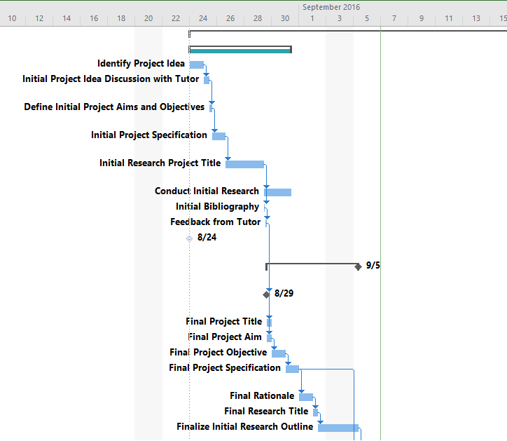

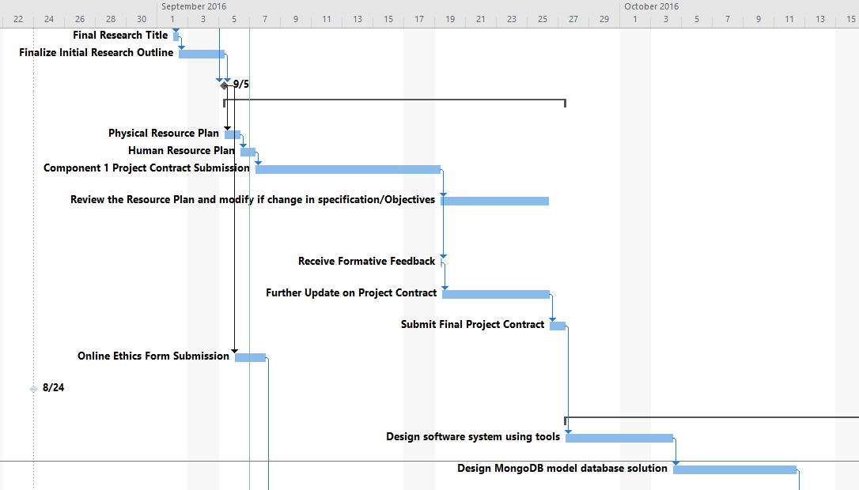

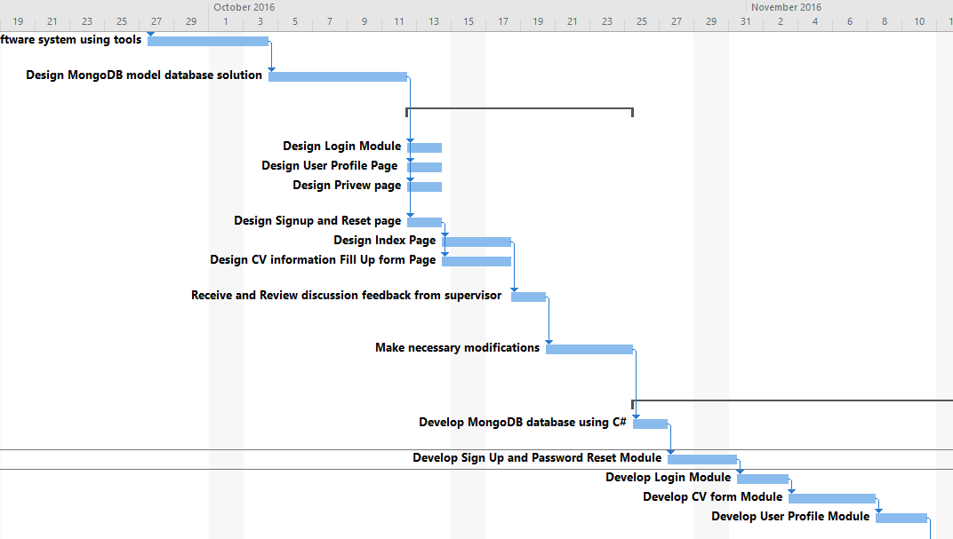

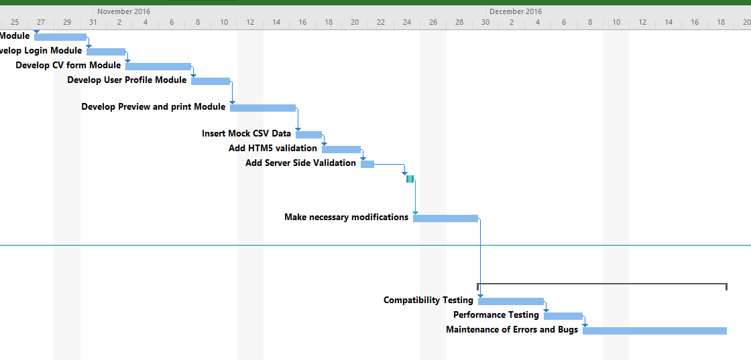

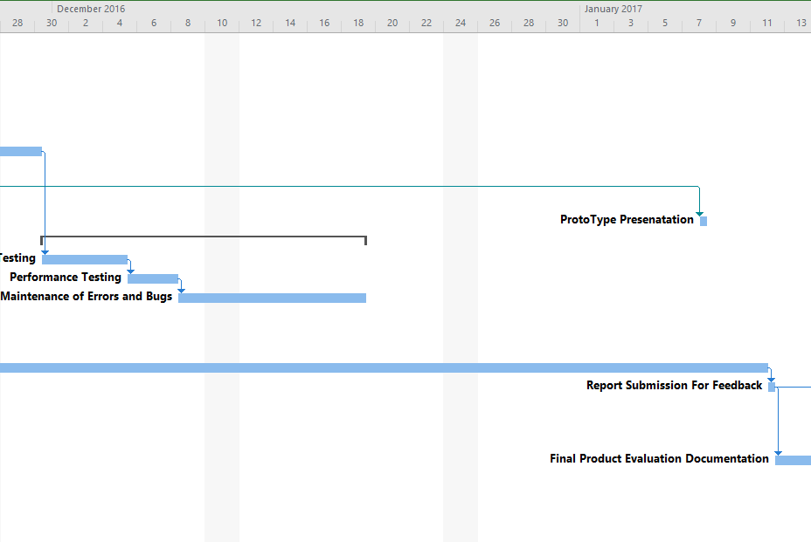

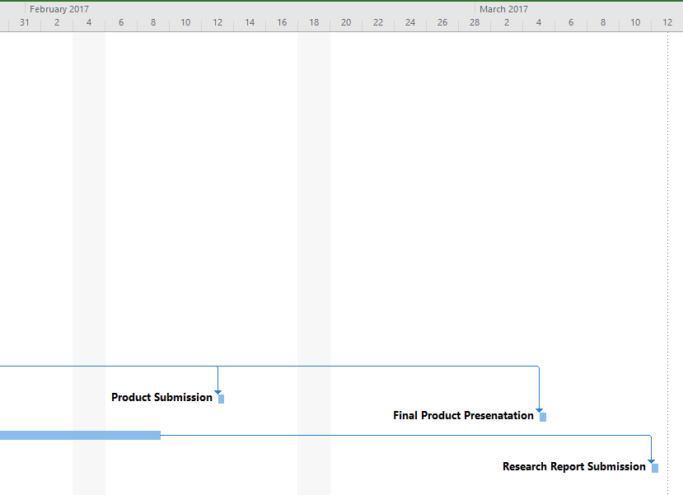

RESEARCH
Title of my Research Report: Comprehensive study on NoSQL Database technology
Outline of my Research:

Introduction
Cloud computing and Internet have developed a lot in recent years. Big data or internet of things are no more new terms when it comes to information technology. Traditional relational database management system also known as RDBMS are facing immense challenge to provide high-performance while storing and processing of big data. In large-concurrency system and large scale, relational database looked to be insufficient solution. Alternatively, to address these problem developers are using NoSQL as database solution. Homan (2015) writes, NoSQL is schema-free data model technology and has ability to process very large number of data. This project would conduct critical study on characteristics, benefits and limitations of NoSQL.

According to Fowler (2016) while using traditional relational database, to retrieve particular data from number of table at once i.e. by joining them, query needs to access all of the tables. Here each table have constraints as well. This reduces the speed of retrieval process. In the other hand NoSQL, does not have to face such issue as all data are located in single document. This makes retrieval process quicker. But data retrieval performance may vary based on the scenario which would be studied in more depth in this project.

Security is one of another aspect of this research project where security aspects of NoSQL technology would be analysed. NoSQL may have some security issues. It does not offer proper security standard (Deka and Bakshi, n.d.). Furthermore, NoSQL technology such as MongoDB may be less secure against attacks such as JSON attack or Rest injection. Various research being made to strengthen security would also be discussed during the research phase.

PHYSICAL RESOURCE
The hardware and software I require to complete my Project successfully:
Item (Hardware or Software) | Source (Faculty, own or specified other organisation)
- Dell Laptop [N5110 Inspiron 15R]  [Development and documentation] | Own
- Windows 10 [64bit]  [Operating System] | Own
- Visual Studio 15 [Community Edition]  [Programming IDE] | Own
- Windows Office 2016  [For Documentation and presentation preparation] | Own
- Windows Visio 2016  [For system planning and designing] | Own
- Windows Projects 2016  [For Gantt chart and WBS development] | Own
- GIT  [Source control solution for safety] | Own
- Brackets 1.7  [For easier front end designing] | Own
- Rob mongo [Windows robomongo-0.9.0]  [For MongoDB management] | Own
- Web Browser- Chrome 52.0.2743.116, Mozilla 48.02 etc.  [For development and testing] | Own
HUMAN RESOURCE
I am working on my Project with the following people
Student 3:  Atut Gorkhali | Student I.D.:77178367
Course:  Project Production | Personal Tutor Name: Basanta Joshi
INITIAL BIBLIOGRAPHY
- Deka, G. and Bakshi, S. (n.d.). Handbook of research on securing cloud-based databases with biometric applications.
- Fowler, A. (2016). Common Features of NoSQL - dummies. [online] Dummies. Available at: http://www.dummies.com/programming/big-data/common-features-of-nosql/ [Accessed 27 Aug. 2016].
- Gupta Edward, S. and Sabharwal, N. (2015). Practical MongoDB. Apress, pp.17-19.
- Jacqueline, J. (2016). Relational vs. non-relational databases: Which one is right for you? [online] Plural sight. Available at: https://www.pluralsight.com/blog/software-development/relational-non-relational-databases [Accessed 27 Aug. 2016].
- Kitchin, R. and McArdle, G. 2016. What makes Big Data, Big Data? Exploring the ontological characteristics of 26 datasets. Big Data & Society. 3(1)
- Leavitt, N. 2010. Will NoSQL Databases Live Up to Their Promise? Computer. 43(2), pp.12-14.
- McCreary, D. and Kelly, A. 2014. Making sense of NoSQL. Shelter Island, NY: Manning.
- Ming Wu, C. 2015. Comparisons Between MongoDB and MS-SQL Databases on the TWC Website. American Journal of Software Engineering and Applications. 4(2), p.35.
- Nepaliya, P. and Gupta, P. 2015. Performance Analysis of NoSQL Databases. International Journal of Computer Applications. 127(12), pp.36-39.
- Patel, J. 2016. Operational NoSQL Systems: What's New and What's Next? Computer. 49(4), pp.23-30.
- Cattell, R. 2010. Scalable SQL and NoSQL Data stores. SIGMOD Records Vol 39 pp.12-27
- Stonebraker, M. 2010. SQL databases v. NoSQL databases. Communications of the ACM. 53(4), p.10.
- Tiwari, S. 2011. Professional NoSQL. Hoboken, N.J.: Wiley.
- Vaish, G. 2013. Getting started with NoSQL. Birmingham: Packt Publishing.
- Chodorow, K. & Dirolf, M. (2010) MongoDB. Sebastopol, Calif., O'Reilly Media.
- Parker, Z., Poe, S. & Vrbsky, S. (2013) Comparing NoSQL MongoDB to an SQL DB. New York, ACM.

